# Project: Holonomic Consensus Architecture for Solana HFT Bot

## 1. Project Goal

The primary goal of this project is to design and implement a state-of-the-art, high-performance decision-making engine for a High-Frequency Trading (HFT) bot operating on the Solana blockchain. This engine must be designed to work in close cooperation with the nonce_pool.rs and rpc_manager.rs execution modules. Files with the full code for these modules can be found in the repository.

This system, named the **Holonomic Consensus Architecture (HCA)**, is designed to provide a structural, resilient advantage by moving beyond fragile, timing-based execution strategies. It focuses on creating an adaptive, self-correcting model of the network's state to achieve minimal time-to-finality for transactions while being robust against network noise, latency, and transient failures.

This document details the architecture of the strategic "brain" of the bot, which interfaces with and commands the executive modules (NonceManager, TransactionBuilder).

Relationship and functions of components schema:

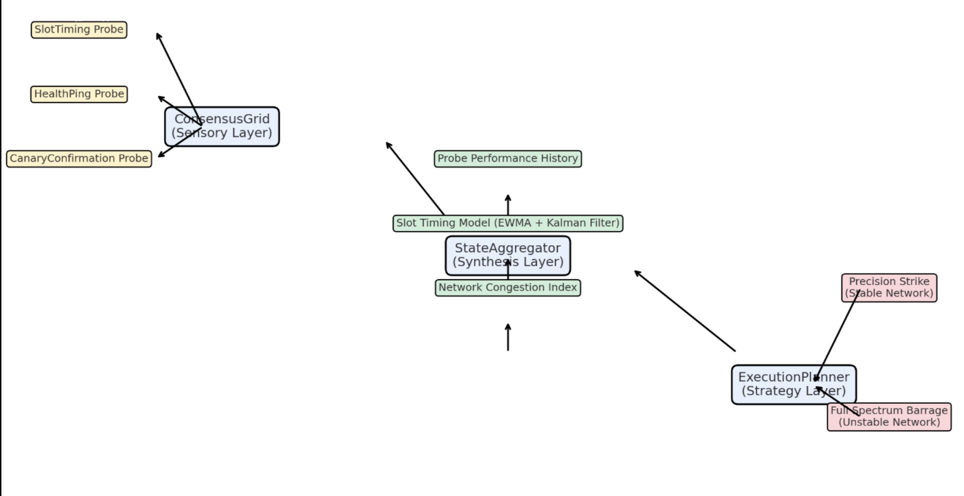

## 2. Core Philosophy: Topological Protection

The guiding principle of the HCA is **Topological Protection**. This concept is borrowed from topological quantum computing, where information is encoded non-locally across an entangled system, making it immune to localized disturbances.

In our context, the bot's "state"—its high-confidence understanding of network timing and health—is not derived from a single, fragile measurement (like a single RPC ping or slot update). Instead, it is encoded in the **holistic consensus of a distributed, internal network of sensors**.

This architecture makes the bot's decision-making process resilient to external factors like RPC latency, network jitter, or skipped slots. A failure in one sensory channel becomes mere "noise" to be filtered, not a catastrophic failure point.

## 3. Architectural Overview

The HCA is a three-layer, state-driven system designed for a clear separation of concerns.

1. **The Sensory Layer: ConsensusGrid**
   * **Function:** Gathers high-frequency, redundant, and often conflicting raw data from the Solana network. It acts as the system's distributed nervous system.
2. **The Synthesis Layer: StateAggregator**
   * **Function:** Ingests the noisy data stream from the ConsensusGrid and synthesizes it into a single, coherent, and **probabilistic** model of the network's current state. It filters the noise to find the signal.
3. **The Strategy Layer: ExecutionPlanner**
   * **Function:** The decision-making engine. It uses the high-confidence probabilistic model to select and trigger the optimal transaction dispatch strategy.

## 4. Module Deep Dive

### 4.1. ConsensusGrid (The Sensory Layer)

The ConsensusGrid replaces a simplistic RpcManager. It is a living, self-monitoring network of probes designed to create a multi-dimensional picture of the network's health.

* **Structure:** Manages a pool of independent, lightweight asynchronous tasks (tokio::spawn), where each task is a **Probe**.
* **Probe Types:** For each configured RPC endpoint (from multiple providers and geographic locations), the grid spawns several specialized probes:
  + **SlotTimingProbe (WebSocket):** Subscribes to slotSubscribe and does nothing but report the arrival time of new slot notifications. This provides the raw heartbeat of the network.
  + **HealthPingProbe (HTTP):** Runs in a high-frequency loop, executing lightweight requests (getHealth) to measure real-time latency and jitter.
  + **CanaryConfirmationProbe (HTTP):** The most advanced probe. It periodically sends tiny, inexpensive transactions (e.g., a 1-lamport self-transfer) and measures the true time-to-confirmation. This is the ultimate metric for network congestion.
* **Output:** The ConsensusGrid emits a continuous, high-volume stream of standardized ProbeReport messages (e.g., SlotUpdate, HealthPingReport) to the StateAggregator.

### 4.2. StateAggregator (The Synthesis Layer)

This module is the central nervous system, translating the chaos of raw sensory data into a clean, actionable model.

* **Structure:** A central processing loop that consumes ProbeReports and continuously updates an internal NetworkModel.
* **Internal NetworkModel:** This is a statistical, not a literal, representation.
  + probe_performance_history: Stores historical data (latency, success rate) for every probe, used for weighting their inputs.
  + slot_timing_model: Uses algorithms like **Exponentially Weighted Moving Averages (EWMA)** to smooth slot durations and a **Kalman Filter** to predict the start time of the next slot with a calculated confidence interval (e.g., "95% probability the slot will end in [T-15ms, T+20ms]).
  + network_congestion_index: A synthesized score (0.0 to 1.0) based on canary confirmation times and RPC error rates.
* **Operation:**
  1. **Ingest:** Consumes reports from the ConsensusGrid.
  2. **Filter:** Applies outlier rejection to discard anomalous data points.
  3. **Synthesize:** Uses the valid data to correct its internal model, giving more weight to reports from historically reliable probes. The Kalman Filter is ideal for this, as it elegantly handles noisy inputs to produce a smooth, predictive output.
* **Output:** Publishes the updated NetworkModel via a tokio::sync::broadcast channel to any subscribed modules (primarily the ExecutionPlanner).

### 4.3. ExecutionPlanner (The Strategy Layer)

The ExecutionPlanner is the bot's strategic brain. It operates on the high-confidence model from the StateAggregator to make the final, adaptive decision to "fire."

* **Structure:** A state machine that subscribes to the NetworkModel and holds references to executive modules.
* **Operation:** When an external signal to "buy" is received, it does not execute a hardcoded plan. It analyzes the current NetworkModel and selects the optimal strategy:
  + **Scenario A: High-Confidence Network State** (e.g., low jitter, low congestion, narrow slot timing confidence interval).
    - **Strategy Selected:** Precision Strike.
    - **Action:** Request a small number of nonces (e.g., 2) from the NonceManager. Request the top 2 healthiest RPCs from the ConsensusGrid. Execute a minimal 2x2 "Quantum Race," targeting the 90th percentile of the predicted slot-end window.
  + **Scenario B: Low-Confidence Network State** (e.g., high jitter, reports of congestion, wide slot timing confidence interval).
    - **Strategy Selected:** Full Spectrum Barrage (the full Quantum Race).
    - **Action:** Request a large number of nonces (e.g., 5). Request the top 5 RPCs. Execute a massive 5x5 "Quantum Race," targeting an earlier percentile of the predicted window to maximize the chances of landing a transaction.

## 5. Required Supporting (Executive) Modules

The HCA is the "brain" and requires connection to the "muscles." It assumes the existence of two highly-optimized, independent modules:

1. **NonceManager (Ammunition Magazine):**
   * **Required Architecture:** A stateful, high-throughput manager as designed in our previous discussions. It **must** support:
     + State tracking (Available, InFlight, RequiresAdvance).
     + Immediate, non-blocking requests for multiple available nonces.
     + A parallel, event-driven (WebSocket) background reload mechanism.
   * **Interaction:** The ExecutionPlanner commands the NonceManager (request_available(5)), which provides the necessary, independent transaction streams for the chosen strategy.
2. **TransactionBuilder (Armorer):**
   * **Required Architecture:** A specialized module responsible for creating highly-optimized, "lightweight" transactions.
   * **Interaction:** The main bot logic uses this module to construct the base "buy" transaction. The ExecutionPlanner receives this pre-built transaction and focuses solely on the strategy of wrapping it with nonce instructions and dispatching it.

## 6. Implementation Notes

* **Technology Stack:** The architecture is designed for an asynchronous Rust environment using tokio.
* **State Management:** Liberal use of Arc<RwLock<T>> or Arc<Mutex<T>> is required for sharing state (like the NetworkModel or probe histories) safely across tasks.
* **Communication:** tokio::sync::mpsc is ideal for probe reporting, while tokio::sync::broadcast is perfect for publishing the NetworkModel to one or more listeners.
* **Error Handling:** A robust error handling strategy (e.g., using the anyhow crate) is critical. The system must be resilient to individual probe failures, which should be treated as data points, not system-wide errors.